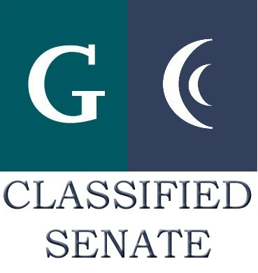
CLASSIFIED SENATE
EXECUTIVE BOARD MEETING
May 3, 2011– Meeting Minutes

Members Present: Maria Briney, Lynne Davidson, Angela Johnson, Karen McCoy, Debi Miller, Avelina Mitchell, Pat Murray, Rocky Rose, Jean Wallace
Members Absent: Patricia Bailey, Joe Balistreri, Wendy Corbin, Monica Farris, Scott Howell, Yvette Macy, JacQ Osborne, Paula Tillery
Members Excused: Maggie Gonzales, Karen Ostegard

1. Welcome and Call to Order
The meeting was called to order at 12:03 p.m.

2. Approval of Minutes from 4/5/11
There was no quorum for approval of minutes. Note: The Chancellor was holding a forum at 12:30p and Board members needed to attend.

3. Continuing Business
- Nominations 2011-2013 E-Board Officers Recorded – Lynne Davidson reported the following nominations were received:

President: Wendy Corbin, Pat Murray, Yvette Macy
Treasurer: Maria Briney, Paula Tillery
Secretary: Debi Miller, Patty Sparks, Lynne Davidson, Monica Farris
District Vice President: Yvette Macy
District M-A-L: Angela Johnson, Yvonne Reid-Hairston
District Senators: JacQ Osborne, Paula Tillery, Jennine Boschock, Nicole Boyer, Karen Kline,
Scott Howell, Pam Wright, Robert Mountain, Hector Schlemmer
Cuyamaca Vice President: Maggie Gonzales, Avelina Mitchell, Kimberly Gioscia
Cuyamaca M-A-L: Patricia Bailey, Avelina Mitchell
Cuyamaca Senators: Avelina Mitchell, Debi Miller, Ken Grimes, Monica Farris, Rocky Rose, Michael Allen, Connie Sterling, Kari Crawford, Melissa Chandler, Judy Shinkan, Maria Gearhart
Grossmont Vice President: Joe Balistreri, Pat Murray
Grossmont M-A-L: Karen Ostegard, Jean Wallace
Grossmont Senators: Joe Balistreri, Pat Murray, Chris Weiss, Mary Eden, Andre Binwahlee,
Dan Lopez, Cindy Eschaves, Glen Macy, Jean Wallace, Patty Sparks, Nancy Ashbury

Lynne Davidson stated she and Paula Tillery would call people who were nominated to ask if they have questions, refer them to the Classified Senate webpage, and ask if they would accept the nomination and serve if elected/appointed. President Miller explained people nominated for more than one position would need to choose only one. Appointments would be made by the E-Board if there are vacant positions. She asked that new people to Classified Senate be called first.

- Classified Staffing Task Force (2nd/Final Read of Template/Rubric)
President Miller distributed the joint CS and CSEA Classified Staffing Prioritization Request Form and the GCCCD Classified Hiring Prioritization Matrix. See President’s report below.

4. Communication
- VP Reports
District: There was no report.
Grossmont: There was no report.
Cuyamaca: There was no report.

Pat Murray distributed by email the CSAD Budget Information. She described the CSAD expenses and asked people to send any outstanding receipts to her soon.

- Treasurer Report: There was no report.

- President’s Report: President Miller distributed the following handouts electronically: Draft April 5 Meeting Minutes, CS Meeting Agenda, joint CS and CSEA Classified Staffing Prioritization Request Form and the GCCCD Classified Hiring Prioritization Matrix. She explained there would be a shortened meeting today due to the Chancellors forum on the District Services Reorganization. She asked people to review the handouts and to send her their comments. She reported training for CS officers would be scheduled after July 1. The Mother Goose Planning would begin soon. There are three guest openings for the Cuyamaca Gala on Saturday, May 14. She asked people to share the information and to email Gwen Nix if interested.

5. Fundraising Activities:
Since there were only a few members left to discuss this, a few suggestions came up.
- Another Cookbook
- Grocery Bags
- 3-Day Walk
- Toner Recycling
- Cell Phone

6. Governance:
- Updates: President Miller reported there would be upcoming Classified Professional Workshops May 13, and 20.

7. New Business
- Mother Goose Parade Planning? See President’s report above.

8. Other
There were no other items brought forward.

The meeting adjourned at 12:30 p.m. The next meeting is June 7, 2011.

